**Sponsors!!!**

We need you. Please consider being a sponsor to help keep our show going year to year. HLAA is non-for-profit and all proceeds go toward bringing our awesome members an exciting weekend each year. Proceeds also go toward yearly youth scholarship awards.

Sponsors will receive special recognition throughout the weekend. While there is no ‘bad stalling’ at this show, stall assignments will also be taken into consideration depending on sponsorship.

Every bit helps. Please consider:

**Autumn Breeze: $25**

**Jack-o-lantern: $50**

**Pumpkin Spice: $100**

**Comfy Campfire: $100+**

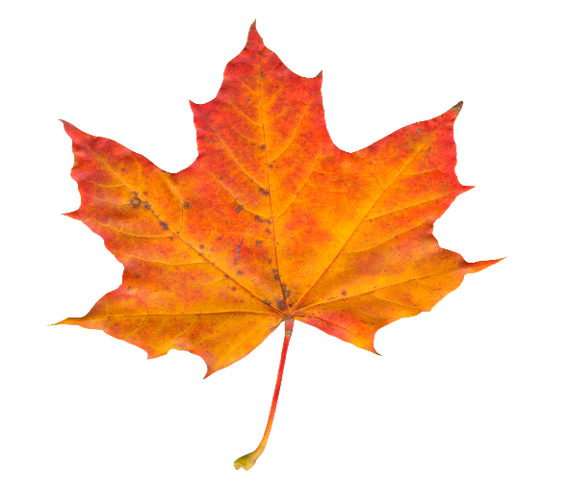

[This Photo](https://freepngimg.com/png/30449-leaf-photo) by Unknown Author is licensed under [CC BY-NC](https://creativecommons.org/licenses/by-nc/3.0/)